**PART 1**

1. <https://swapi.dev/api/people/4>
2. <https://swapi.dev/api/planets/2>
3. <https://swapi.dev/api/starships/10>
4. <https://swapi.dev/api/species/2> <https://swapi.dev/api/people/2>
5. 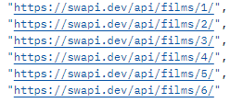<https://swapi.dev/api/people/10>
6. <https://swapi.dev/api/starships/?search=Falcon>

**PART 2**

<https://practiceapi.devmountain.com/api/posts>

<https://practiceapi.devmountain.com/api/posts/filter?text=blue>

application/json